**LẬP TRÌNH HĐT**

**------Con người – Sinh viên**

***// Tao class Connguoi(ten, namsinh,diachi) - Hàm: tao(có và ko doi so), nhap, in***

***// Tao class Sinhvien ke thua tu Connguoi them thuoc tinh (masv, diem1, diem2)***

***// - hàm tao, in, tinh tong diem, tinh diem trung binh***

***// Yeu cau: nhap 1 mang sinh vien***

***// - in mang sinh vien vua nhap***

***// - in thong tin sinh vien co diem cao nhat***

#include<cstdlib>

#include<iostream>

#include<string.h>

using namespace std;

class Connguoi{

private:

char ten[50];

int namsinh;

char diachi[50];

public:

Connguoi(){

strcpy(ten,"Nguyen Tu Toan");

namsinh = 1996;

strcpy(diachi,"Vinh Long");

}

Connguoi(char _ten[50], int _namsinh, char _diachi[50]){

strcpy(ten,_ten);

namsinh = _namsinh;

strcpy(diachi,_diachi);

}

void NhapCN(){

cout<<"Nhap ten: ";

cin.getline(ten,50);

cout<<"Nhap nam sinh: ";

cin>>namsinh;

cin.ignore();

cout<<"Nhap dia chi: ";

cin.getline(diachi,50);

}

void InCN(){

cout<<"\nTen: "<<ten;

cout<<"\nNam sinh: "<<namsinh;

cout<<"\nDia chi: "<<diachi;

}

};

class Sinhvien:public Connguoi{

private:

char masv[10];

float diem1;

float diem2;

public:

Sinhvien(){

strcpy(masv, "14004044");

diem1 = 7.8;

diem2 = 6.8;

}

Sinhvien(char _masv[10], float _diem1, float _diem2){

strcpy(masv, _masv);

diem1 = _diem1;

diem2 = _diem2;

}

float diemtrungbinh(){

return (diem1+diem2)/2;

}

void NhapSV(){

NhapCN();

cout<<"Nhap ma sinh vien: ";

cin.getline(masv,50);

cout<<"Nhap diem 1: ";

cin>>diem1;

cout<<"Nhap diem 2: ";

cin>>diem2;

cin.ignore();

}

void InSV(){

InCN();

cout<<"\nMa sinh vien: "<<masv;

cout<<"\nDiem 1: "<<diem1;

cout<<"\nDiem 2: "<<diem2;

cout<<"\nDiem trung binh: "<<diemtrungbinh();

}

};

main(){

int n;

cout<<"Nhap so luong sinh vien: ";

cin>>n;

cin.ignore();

Sinhvien sv[n];

for(int i=0;i<n;i++){

sv[i].NhapSV();

}

float max;

for(int i=0;i<n;i++){

if(sv[i].diemtrungbinh()>max) max = sv[i].diemtrungbinh();

}

cout<<"\nSinh vien cos diem cao nhat:\n";

for(int i=0;i<n;i++){

if(sv[i].diemtrungbinh()==max) sv[i].InSV();

}

return 0;

}

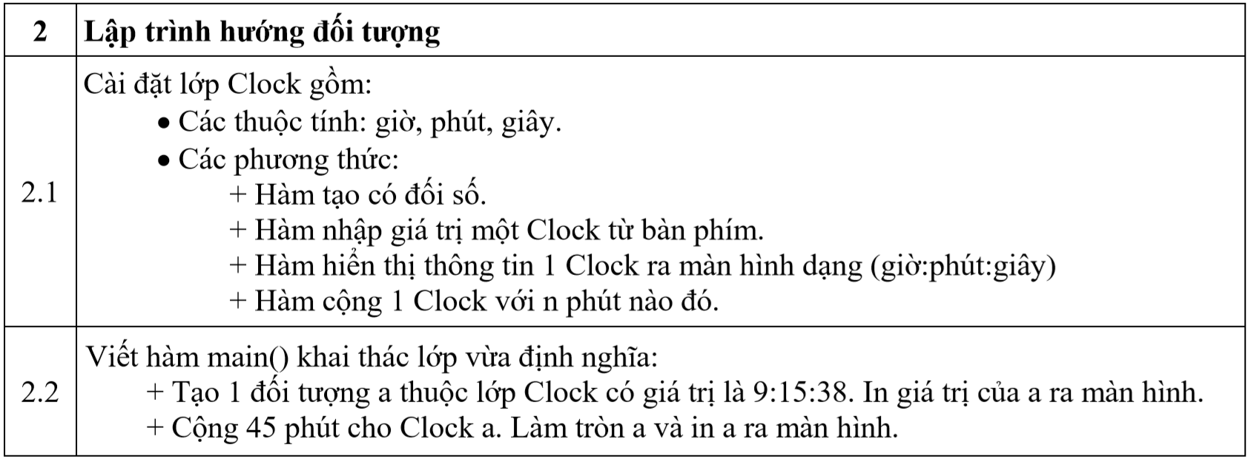

#include<cstdlib>

#include<iostream>

using namespace std;

class Clock{

private:

int gio;

int phut;

int giay;

public:

Clock(int _gio, int _phut, int _giay){

gio = _gio;

phut = _phut;

giay = _giay;

}

void NhapClock(){

cout<<"Nhap gio: ";

cin>>gio;

cout<<"Nhap phut: ";

cin>>phut;

cout<<"Nhap giay: ";

cin>>giay;

}

void InClock(){

cout<<gio<<":"<<phut<<":"<<giay;

}

void ThemPhut(int _phut){

gio+= (phut+_phut)/60;

phut = (phut+_phut)%60;

}

};

main(){

cout<<"===== CLOCK =====\n";

Clock a(9,15,38);

cout<<"Gio la: ";a.InClock();

a.ThemPhut(45);

cout<<"\nGio them 45 phut la: "; a.InClock();

return 0;

}

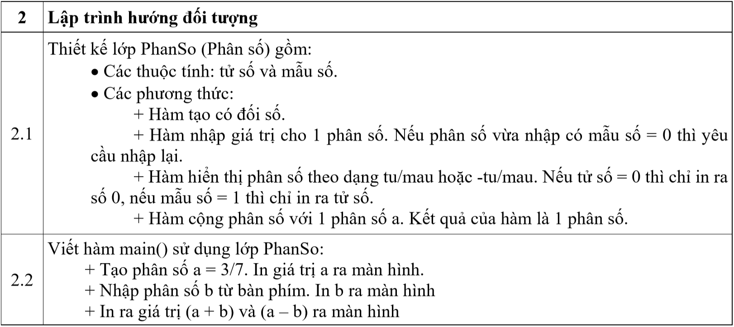

#include<cstdlib>

#include<iostream>

using namespace std;

class PhanSo{

private:

int tu;

int mau;

public:

PhanSo(){

tu=1;

mau=1;

}

PhanSo(int _tu, int _mau){

tu = _tu;

mau = _mau;

}

void NhapPhanSo(){

cout<<"Nhap tu: ";

cin>>tu;

// lenh nhay lap lai khi nhap sai mau

nhapmau:

cout<<"Nhap mau: ";

cin>>mau;

if(mau==0){

cout<<"Mau so phai khac 0, nhap lai!\n";

goto nhapmau;

}

}

void InPhanSo(){

if(tu==0) cout<<"0";

else if(tu==mau){

cout<<"1";

}

else if(tu*mau<0){

cout<<"-"<<tu<<"/"<<mau;

}

else{

cout<<tu<<"/"<<mau;

}

}

PhanSo & operator+(PhanSo &a){ // qua tai +

PhanSo t;

t.tu = tu*a.mau + a.tu*mau;

t.mau = mau*a.mau;

return t;

}

PhanSo & operator-(PhanSo &a){ // qua tai -

PhanSo t;

t.tu = tu*a.mau - a.tu*mau;

t.mau = mau*a.mau;

return t;

}

};

main(){

PhanSo a(3,7),b,cong,tru;

a.InPhanSo();

cout<<"\nNhap phan so b: \n";

b.NhapPhanSo();

cong = a+b;

tru = a-b;

cout<<"Ket qua cong 2 phan so: "; cong.InPhanSo();

cout<<"\nKet qua tru 2 phan so: "; tru.InPhanSo();

return 0;

}

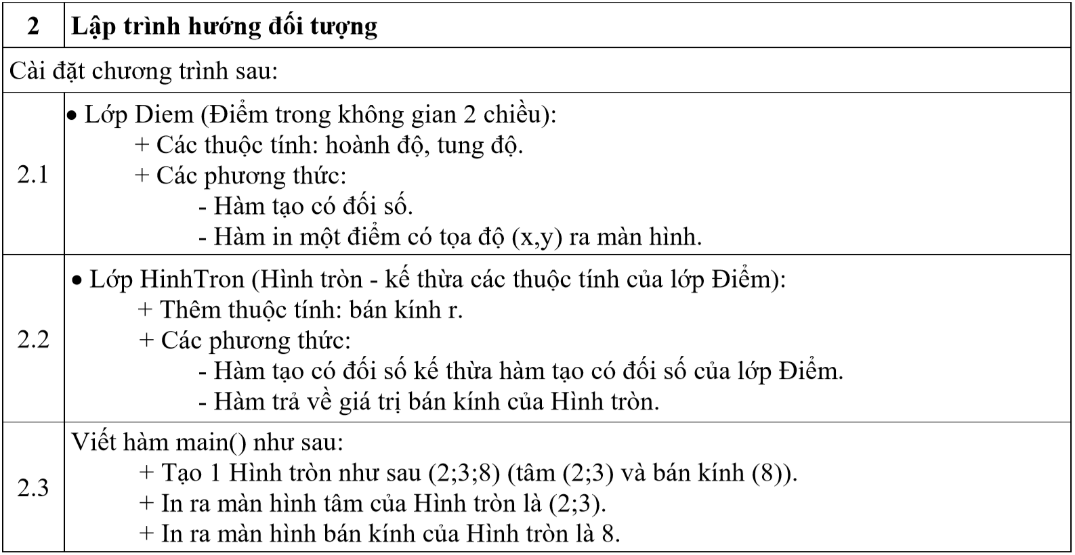

#include<cstdlib>

#include<iostream>

using namespace std;

class Diem{

private:

int x;

int y;

public:

Diem(){

x = 0;

y = 0;

}

Diem(int _x, int _y){

x = _x;

y = _y;

}

void InDiem(){

cout<<"("<<x<<","<<y<<")";

}

};

class HinhTron : public Diem{

private:

int r;

public:

HinhTron(){

r = 0;

}

HinhTron(int _x, int _y, int _r) : Diem(_x,_y){

r = _r;

}

int InBanKinh(){

return r;

}

};

main(){

HinhTron a(2,3,8);

cout<<"Tam hinh tron: ";a.InDiem();

cout<<"\nBan kinh hinh trong: "<<a.InBanKinh();

return 0;

}

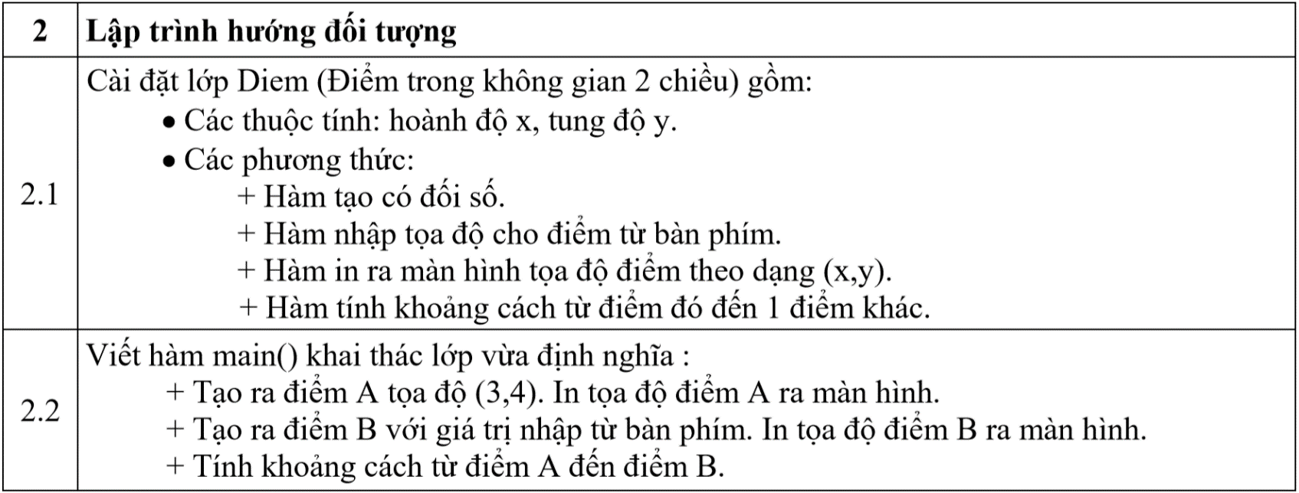

#include<cstdlib>

#include<iostream>

#include<math.h>

using namespace std;

class Diem{

private:

int x;

int y;

public:

Diem(){

x = 0;

y = 0;

}

Diem(int _x, int _y){

x = _x;

y = _y;

}

void InDiem(){

cout<<"("<<x<<","<<y<<")";

}

void NhapDiem(){

cout<<"Nhap toa do x: ";

cin>>x;

cout<<"Nhap toa do y: ";

cin>>y;

}

float KhoangCach(Diem a){

return sqrt(pow(x-a.x,2)+pow(y-a.y,2));

}

};

main(){

Diem a(3,4),b;

cout<<"Toa do diem a: ";a.InDiem();

cout<<"\nNhap toa do b:\n";

b.NhapDiem();

cout<<"Nhap toa do diem b: ";b.InDiem();

cout<<"\nKhoang cach a -> b : "<<a.KhoangCach(b);

return 0;

}

**---------------Vé máy bay**

#include<cstdlib>

#include<iostream>

using namespace std;

class Ve{

private:

char Sohieu[20];

char Den[50];

char Di[50];

float Dodai;

long Mucgiatran;

public:

void Nhapmb(){

cout<<"Nhap so hieu may bay: ";

cin.ignore();

cin.getline(Sohieu,20);

cout<<"Nhap ten san bay di: ";

cin.getline(Di,50);

cout<<"Nhap ten san bay den: ";

cin.getline(Den,50);

cout<<"Nhap do dai hanh trinh: ";

cin>>Dodai;

cout<<"Muc gia: ";

cin>>Mucgiatran;

}

long Giave(){

if(Dodai>1200) return (Mucgiatran*1.5);

else

if(Dodai>500 && Dodai<=1200) return (Mucgiatran*1.2);

else

return Mucgiatran;

}

void In(){

cout<<"\nSo hieu may bay: "<<Sohieu;

cout<<"\nTen san bay di: "<<Di;

cout<<"\nTen san bay den: "<<Den;

cout<<"\nDo dai hanh trinh: "<<Dodai;

cout<<"\nMuc gia tran: "<<Giave();

}

};

class Hanhkhach{

private:

char Makhach[20];

char Hoten[50];

char Diachi[50];

int Sove;

Ve a[100];

public:

void Nhapkhach(){

cout<<"Nhap ma khach: ";

cin.ignore();

cin.getline(Makhach,20);

cout<<"Nhap ho ten khach: ";

cin.getline(Hoten, 50);

cout<<"Nhap dia chi khach: ";

cin.getline(Diachi,50);

cout<<"Nhap so ve khach mua: ";

cin>>Sove;

for(int i = 1; i<=Sove; i++){

cout<<"=====Nhap thong tin ve thu "<<i<<"=====\n";

a[i].Nhapmb();

}

}

long Tinhtien(){

long Tong;

int i;

for(i=1;i<=Sove;i++){

Tong = Tong + a[i].Giave();

}

return Tong;

}

void Inkhach(){

cout<<"\n=====THONG TIN KHACH HANG=====\n";

cout<<"Ma khach: "<<Makhach;

cout<<"\nTen khach: "<<Hoten;

cout<<"\nDia chi: "<<Diachi;

cout<<"\nSo ve: "<<Sove;

cout<<"\n-----Thonng tin ve-----\n";

for( int i=1;i<=Sove;i++){

a[i].In();

}

cout<<"\nTong tien hanh khach phai tra: "<<Tinhtien();

}

int Tongsove(){

return Sove;

}

};

main()

{

int n,j;

Hanhkhach b[30];

do{

cout<<"Cho biet so luong khach hang: "; cin>>n;

}while(n<2 || n>30);

for (j=1;j<=n;j++){

cout<<"\n===== NHAP KHACH HANG THU "<<j<<" =====\n";

b[j].Nhapkhach();

}

for (j=1;j<=n;j++){

if(b[j].Tongsove()>3) b[j].Inkhach();

}

}